Library Visit: Find sources for your current event essay
From the Articles & Databases page, select Gale Opposing Viewpoints in Context | 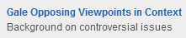
Select Browse Issues
Find topic that provides background information for your essay | 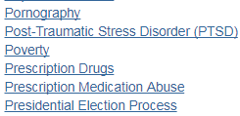
Review the topic overview | 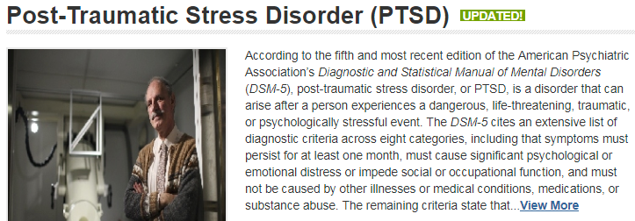
Email yourself a copy of the articles you find | 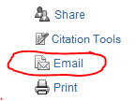
Google Santa Cruz County Assessment Project

Pick one section of the  report to review | 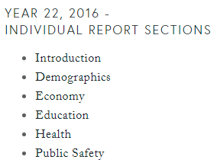
Gale Opposing Viewpoints provides the MLA citation under citation tools  You will have to create your own MLA citation for websites.  Here is a sample citation | “Economy.” Santa Cruz Community Assessment Project, 2016, https://static1.squarespace.com/static/5176dcd7e4b0e5c0dba41ee0/t/584f356b03596ea111d3ea51/1481586031897/CAP-22-Economy.pdf
Find any persuasive details or specific examples?
Pick one interesting fact and create an in-text citation below:
- Introduce the source
- Cite it (include a page number if available)
- Say something about the significance of the quote – how it relates to your essay

