ENGL 100 Founds Michelle Morton
Library Orientation Fall 2013 mimorton@cabrillo.edu

From the library website go to  Articles and Databases | 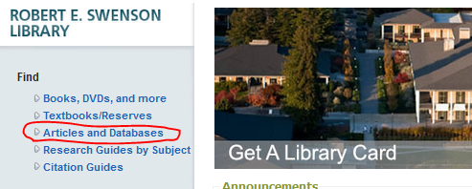
Look for the database Business Source Elite
Search for your article
Click on the title | 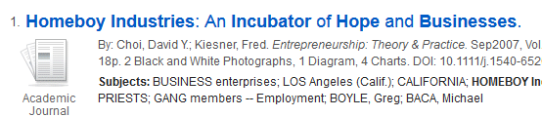
Find the MLA Citation | 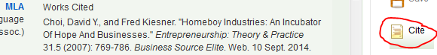
Skim the article – look for PDF Full Text | 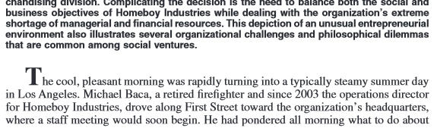
Find something you want to cite for your paper | 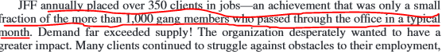

Academic journal, periodical (magazine), or news? | Who is the author? | How long is the article? | Does it include references? | What kind of information does it include?
Create an MLA citation for your works cited list below
Create an in-text citation:
- Introduce the source
- Cite it (include a page number if available)
- Say something about the significance of the quote – how it relates to your research

