Social Justice Research: Secondary Sources
Look for background information on your topic and brainstorm research questions
From the library homepage, go to Articles and Databases
Select the CQ Researcher Database
Split your group into two and look for these two reports:
- Juvenile Justice
- Sentencing reform

Review the introduction to each report and take some notes
Look at the table of contents on the left. Pick 3 sections you want to use

Divide the report up among members of your group. Skim your section
Print a copy of the report and email the entire report to everyone in your group
Look for citation tool.  Change from APA to MLA.  Copy the MLA citation below for your works cited list | 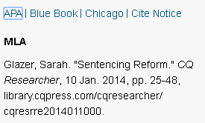
Review your report.

What are your research questions?

Try to go from broad and general to narrow and specific.

Pick one interesting fact or quote and create an in-text citation:
- Introduce the source
- Cite the source in parenthesis
- Say something about the significance of the quote – how it relates to your social justice research

