Social Justice Research: Secondary Sources
Look for background information on your topic and brainstorm research questions
From the library homepage, go to Articles and Databases
Select the SuperSearch all Databases
Search the keywords
Homeland security environmental justice

Select the article Homeland Security by Javier Sierra  Review and take some notes | 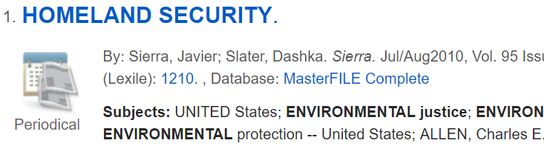
Print a copy of the article and email the article to everyone in your group
Get a copy of the MLA citation | 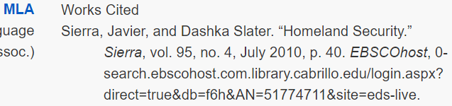
Review your article.

What is happening?

How is it happening?

Who is effected by this issue?

Why should we care?

Pick one interesting fact or quote and create an in-text citation:
- Introduce the source
- Cite the source in parenthesis
- Say something about the significance of the quote – how it relates to your social justice research
Looking for more information?
Search the keywords
environmental justice

Select the Research Starter Environmental justice and environmental racism
Email yourself the article

