Social Justice Research: Secondary Sources
Look for background information on your topic and brainstorm research questions
From the library homepage, go to Articles and Databases
Select the Gale Opposing Viewpoints Database
Search for Education

Review the over view on education
Email yourself the article | 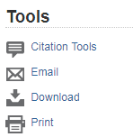
Scroll down and click on Reference | 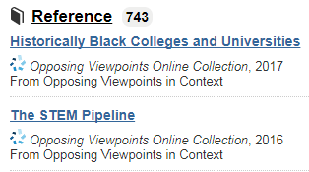
Pick one more source | 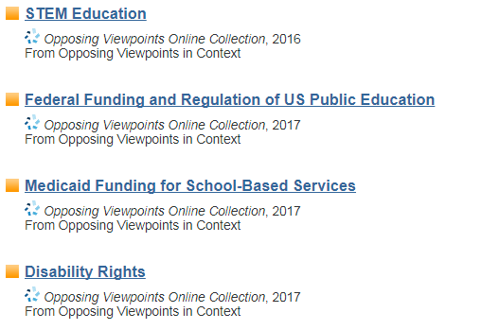
Email yourself the article
Review your sources.

What are your research questions?

Try to go from broad and general to narrow and specific.

Find the MLA citation | 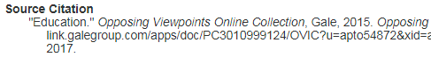
Pick one interesting fact or quote and create an in-text citation:
- Introduce the source
- Cite the source in parenthesis
- Say something about the significance of the quote – how it relates to your social justice research

