ENGL 1A Najarro Library Visit I

- Pick an encyclopedia article on some aspect of social identity you want to learn more about
Copy the MLA citation
Record notes below on how this article relates to what your research question
Encyclopedia Article on Social Identity
MLA Citation
Notes

- Go to the SuperSearch on the library website
Select Advanced Search
Do a search using the keywords below
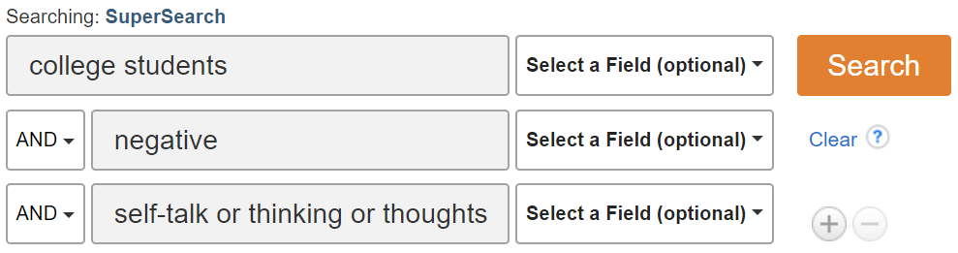
Limit your dates to articles from the last 10 years | 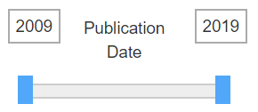
Record notes below on how this article relates to what your research question
SuperSearch Article
MLA Citation
Notes

- Review your research question. How do these two articles – one on social identity and one on negative self-talk – help you think about this question?
Write some notes below
Pick at least one quote from each article you want to use for your paper

