KIN 3 Library Orientation Michelle Morton
Students in Group:
1. Find an eBook in the Library Catalog and Send yourself a Chapter
Search “sports” in the library catalog | 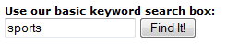
Pick an eBook that looks interesting | 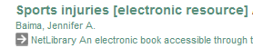
Email yourself a chapter from the book | 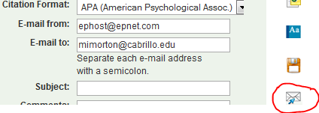
2. Find a Print Book in the Library Catalog
Go back to your results list  Select a Print Book | 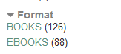
Make sure the status is Not Checked Out
Check the location: is it in the Main Stacks, Aptos Reserve, Watsonville, Folio Stacks, or some other location? | 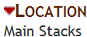
Write down the call number and go get your book!  Once you find it: are there other books nearby on the same topic? | 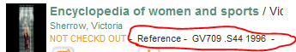

- Bring a picture ID to the Circulation Desk and ask for a library card.

- Find the Reference Instruction Desk and the Technical Help Desk in the library. Ask the people that work there what they do.

- Find the student computer stations and the print stations. How do you put money on your print account?

- Find the current periodicals area. Pick a magazine or book that looks interesting. Bring it back to the classroom.
7. Find the new books area. Pick a book that looks interesting. Bring it back to the classroom.

- Find some art in the library. Ask a staff person if you need help. Have one person in your group take a picture of it and send it to mimorton@cabrillo.edu

- Using the map below, identify possible study areas in the Library. Look around the first and second floors. Where would you study?

Come back to the classroom and present your findings.
