Name:

1. Finding Print Books on Topics Specific to Women
Search your topic in the library catalog
Write down the call number and get the book of the shelf

Bring your student ID so you can get a library card!
Draft a MLA citation | Kirk, Pamela. Sor Juana Inés de la Cruz: Religion, Art, and Feminism. New York: Continum, 1999.
Can’t find any books?  Use WorldCat to look for books in local libraries | 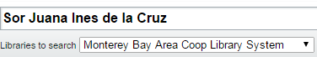
If you find a book you want at another library you can… | - Go pick it up yourself!  - Ask a librarian to order the book for you for free

2. Finding eBooks on Topics Specific to Women
Go to Articles & Databases
Search your topic EBSCO eBook Collection
Email yourself a chapter from a book

Include the MLA citation

3. Finding Articles on Topics Specific to Women
Write down at least 5 keywords related to your topic
Quinciñera Quinceanera Quinceañera Coming-of-Age
Ritual Puberty Social customs Rites Ceremonies

Use your keywords to search for articles in SuperSearch
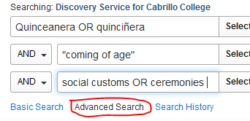
Look for periodicals or magazines
…academic journals
…or newspapers

Email yourself at least one article
Be sure to pick MLA citation format

4. Finding Background Information on Health Topic
Find background information on your health topic using Gale Encyclopedia of Medicine and MedlinePlus
Write down some notes on your topic:

Email or print out your article, including the MLA citation.
For the MedlinePlus website, you will have to create your own MLA citation. Here is an example:
“Depression.” MedlinePlus, 18 Sept. 2017, https://medlineplus.gov/depression.html.

