Library Visit: Find a source for your mini-research paper
From the Articles & Databases page, select Gale Opposing Viewpoints in Context
Select Browse Issues
Find topic that provides background information for your essay

Review the topic overview | 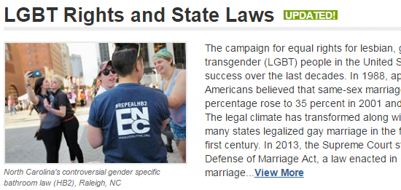
Email yourself a copy of the article | 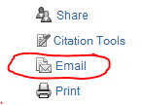
Find the MLA citation for your works cited list under Source Citation.  Copy the MLA citation for your source below. | 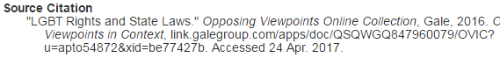
Pick one interesting fact and create an in-text citation below:
- Introduce the source
- Cite it (include a page number if available)
- Say something about the significance of the quote – how it relates to your essay
Pick at least one other source for your essay | 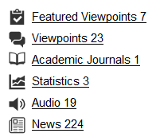
Email yourself a copy of the article
Write a few notes about the source and copy the MLA citation below
Write a few notes about the source and copy the MLA citation below
Write a few notes about the source and copy the MLA citation below

